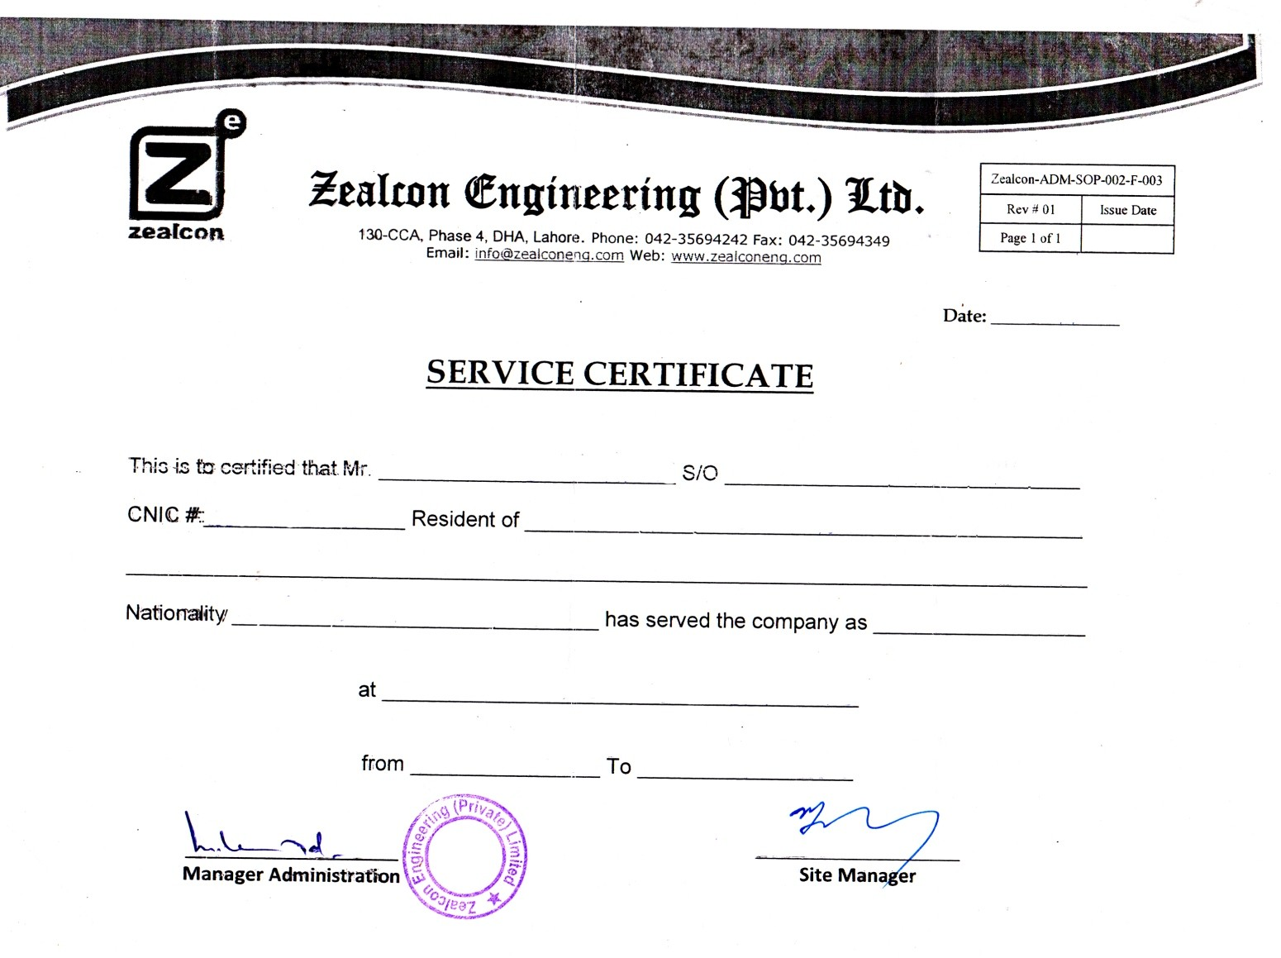

**<To>**

**<To>**

**<Name> <fname>**

**<CNIC> District Multan**

**Pakistani <Designation>**

**Mehar Gas Development Project**

**<From> <To>**